# QuitRunningApps User Guide

QuitRunningApps application is built on SwiftUI for macOS.

## Main Screen

The application will provide a list of running applications. The list is filtered and shows only regular applications as per Apple’s definition: “The application is an ordinary app that appears in the Dock and may have a user interface.”

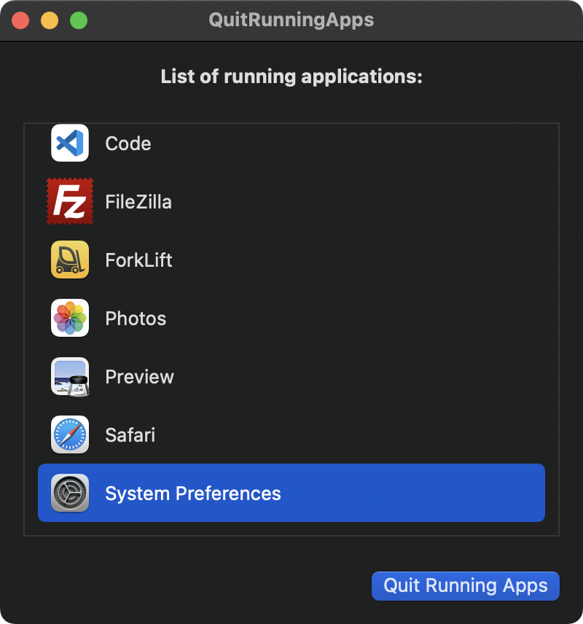

The list of applications is dynamically updated. When a new application is started, it is added to the list and when an application is closed, it is removed from the list.

Pressing the “Quit Running Apps” button will **inform** the applications from the list to quit normally.

In case any of the applications that are being quit has a document open or some other work in progress it will not be closed. The application will ask for open document(s) to be saved or discarded and then close. Each application being closed will handle this process as per its own logic.

The list allows applications to be selected. Selected applications will **not** be informed to quit when the button “Quit Running Apps” is pressed.

## Settings

“Quit this app after all others.”

When selected QuitRunningApps application will quit **after** all other applications are informed to quit. It will **not wait** for them to actually quit.

“Quit macOS Finder app also.”

When selected the list of applications will contain also macOS Finder app. It will be quit together with the rest of the applications from the list.

## Information

Download the latest version from: [quitrunningapps.noavis-dev.eu](https://quitrunningapps.noavis-dev.eu/).